Experiment : 3 Benchmarking of 5G/6G Communication
for IoE Applications based on Throughput, Latency,Reliability and Energy
Efficiency

Objective:
To benchmark and compare 5G and 6G communication technologies for Internet of Everything (IoE) applications based on throughput, latency, reliability, and energy efficiency
Procedure :
- Identify suitable IoE applications and select 5G and 6G communication technologies for comparison.
- Select the performance parameters: throughput, latency, reliability, and energy efficiency.
- Collect or simulate 5G and projected 6G performance data.
- Compare both technologies using tables and graphs based on the selected parameters.
- Analyze the results to determine the suitability of 5G and 6G for different IoE applications.

Tabular column:

IoE Devices | 220 | 350 | 480
Offered Load | 42.24 Mbps | 67.20 Mbps | 92.16 Mbps
Throughput | 41.40 Mbps | 65.86 Mbps | 90.32 Mbps
Latency | 17.31 ms | 30.49 ms | 127.55 ms
Reliability | 89.72 % | 84.83 % | 79.94 %
Energy Efficiency | 6.06 Mbit/J | 4.87 Mbit/J | 3.99 Mbit/J

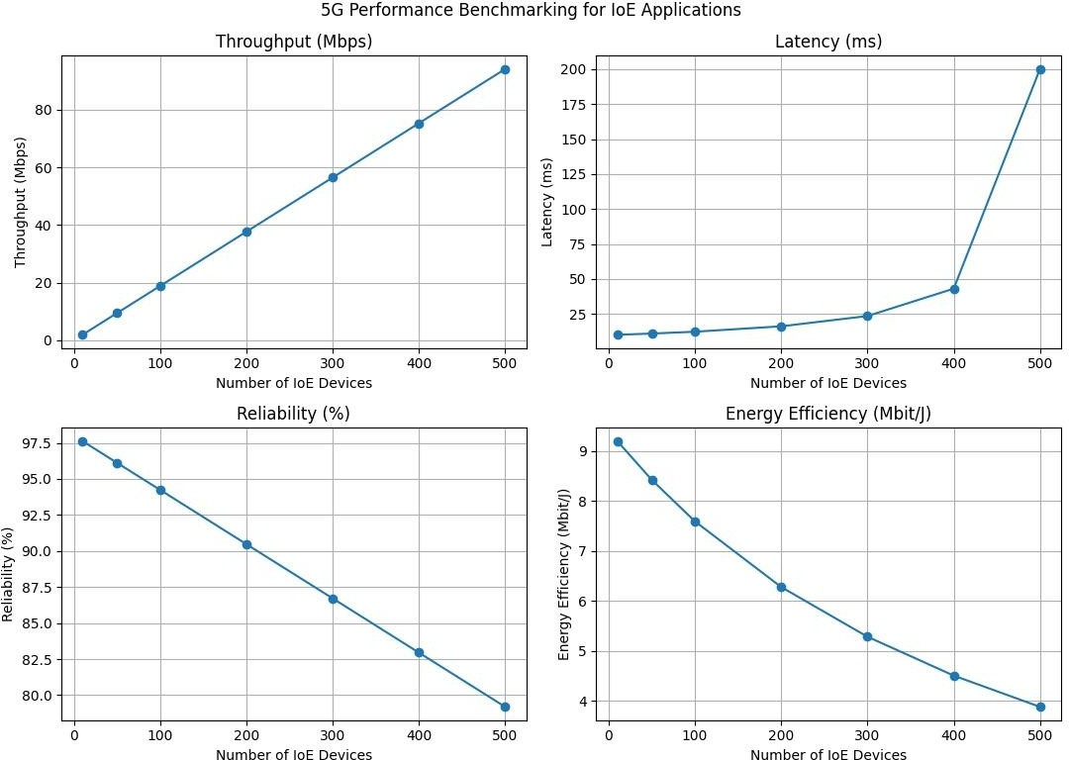

Result :
As the number of IoE devices increases, throughput increases, while latency, reliability, and energy efficiency decrease. Therefore, 5G is suitable for
moderate-load IoE applications, whereas 6G offers higher throughput for high-demand applications but requires improvements in latency, reliability, and
energy efficiency.

